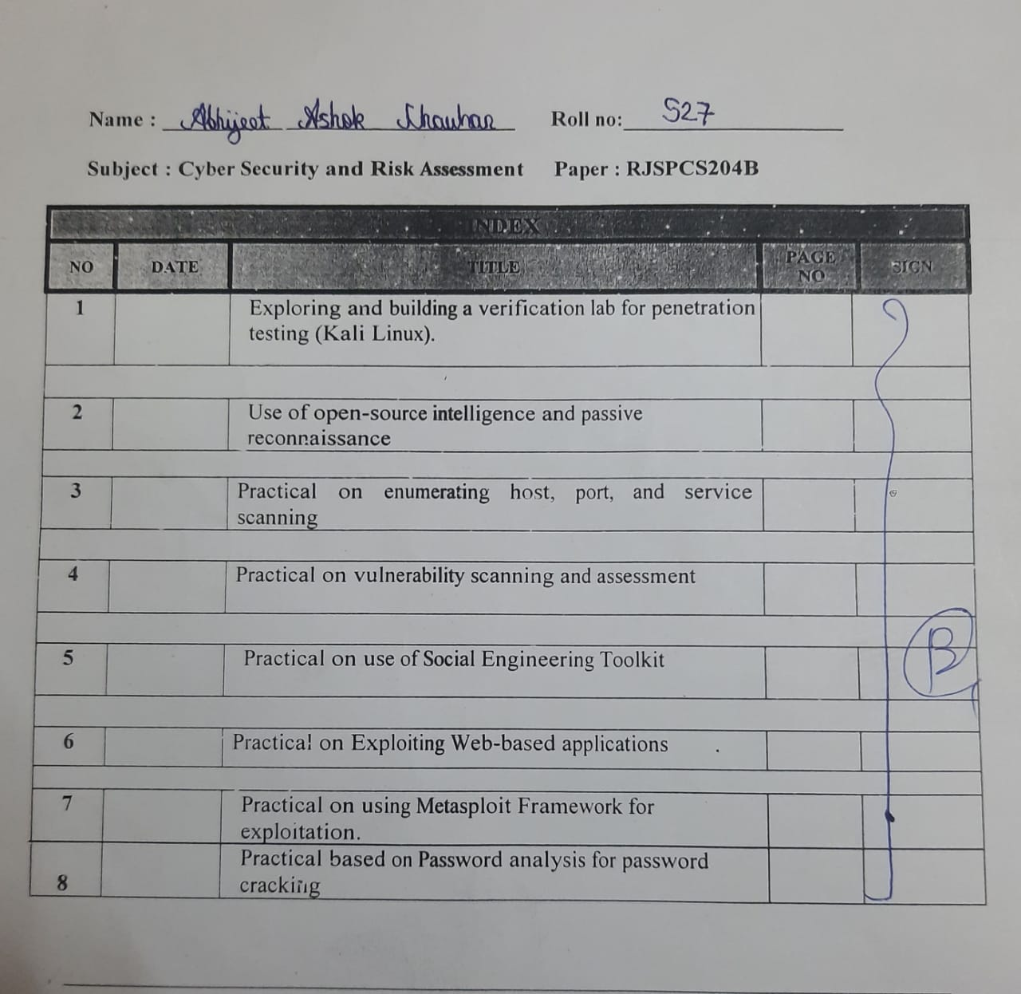

**Practical No 1**

**Aim:**

Exploring and building a verification lab for penetration testing (Kali Linux)

**Step:**

Environment setup

Open kali linux

Turn on power on this virtual machine

Username kali

Password kali

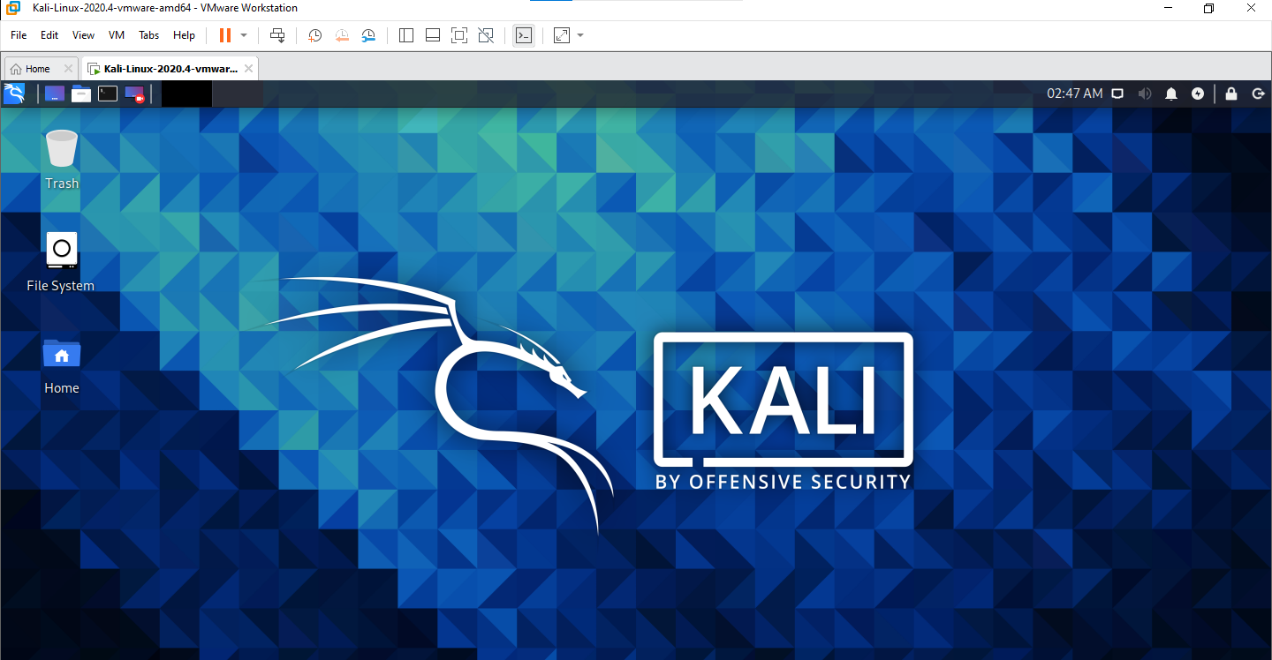

**Practical No 2**

**Aim:**

Uses of open-source intelligence and passive reconnaissance

**Step:**

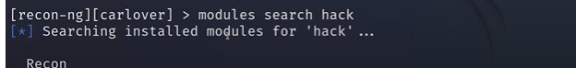



**Practical No 3**

**Aim:**

Practical on enumerating host, port, and service scanning

**Step 1:**

Run command: nmap scanme.org -v

-v :stand for verbose . It provides detailed and extensive output or information

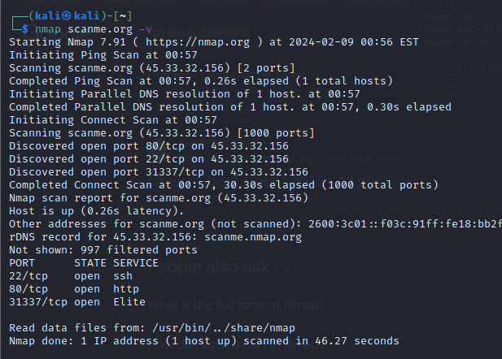

**Step 2:**

Command: nmap -v -T4 scanme.org

-T4: Set timing template (higher is faster)

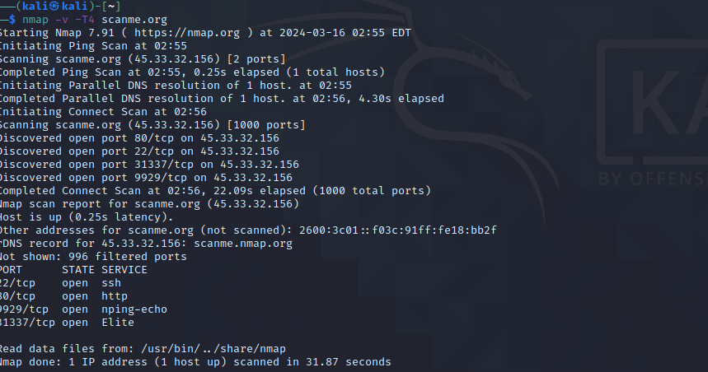

**Step 3:**

command: sudo nmap -v -sT -scanme.org

-sT: Scan TCP

**Step 4:**

Command: sudo nmap -v -O scanme.org

-O :Detect Operating system

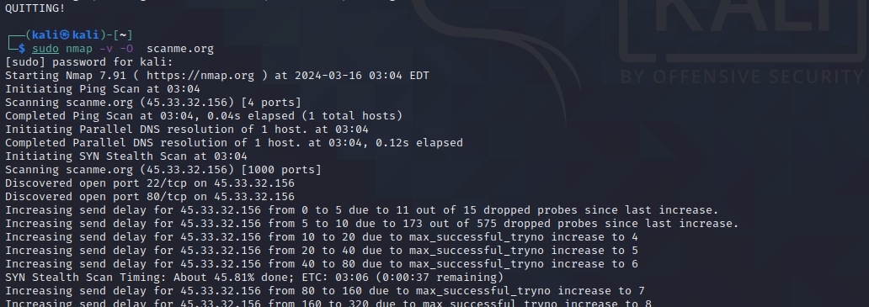

**Step 5:**

Command: sudo nmap -v -A scanme.org

-A aggressive scan

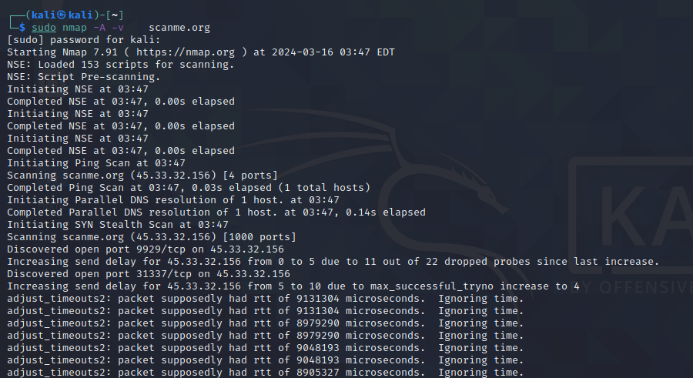

**Practical No 4**

**Aim:**

Practical on vulnerability scanning and assessment.

ZAP

Use can type any domain in url attack box

**Practical No 5**

**Aim:**

Practical on use of Social Engineering Tookit

**Step 1:**

**Step 2:**

New tab

**Practical No 6**

**Aim:**

Practical on Exploit web-based application

Using nmap

**Command:**

sudo nmap -v -sA -O -sV open.spotify.com -T4 --script=vulners

sudo stand for super user

nmap stand for network mapping

-v stand for verbose

-O stand for finding operating system

-sA stand for aggressive scan

-sV stand for version detection

-T4 kuch tho tumlog search karo

--script=vulners it scan vulnerability

Or external k time ye ek command type kar k mat baith jana divided kar k scanning perform karna

Like

sudo nmap -v open.spotify.com

sudo nmap -v open.spotify.com -O

sudo nmap -v open.spotify.com -O -sA

sudo nmap -v open.spotify.com -O -sA --script=vulners

**Practical No 7**

**Aim:**

Practical on using Metasploit Framework for exploitation.

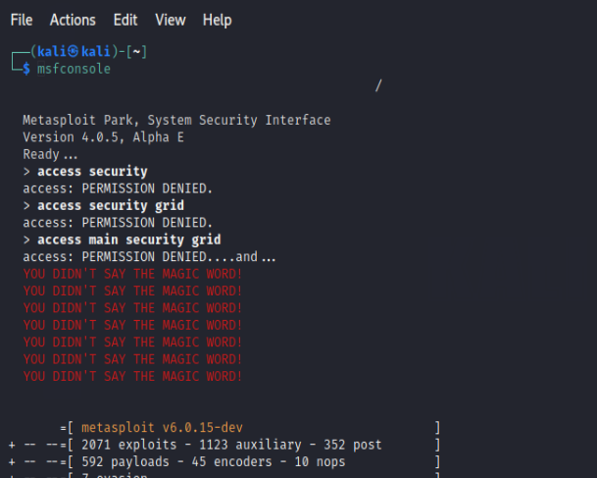





**Practical No 8**

**Aim:**

Practical based on Password analysis for password cracking

Command: crunch 1 2 12345678>wordlist.txt

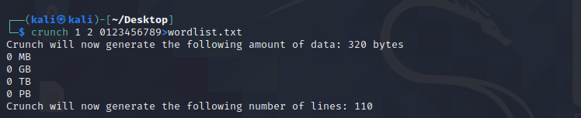

command: crunch 10 10 -t manav^%%%%

